**13X SOP REFERENCE:** [SUN77_SOP_RTA-CM_Selective Translations_v4.0](../../../../../01%20ADMIN/102%20-%20STANDARD%20OPERATING%20PROCEDURE/02%20ENOVIA/02%20COPY%20ELEMENTS/SUN77_SOP_RTA-CM_Selective%20Translations_v4.0.doc)

**SELECTIVE TRANSLATION**

**Note:** Selective Translation process is now via POA.

1. Click the compass button “**My Social and Collaborative Apps**” then click “**Copy & Artwork Management**”

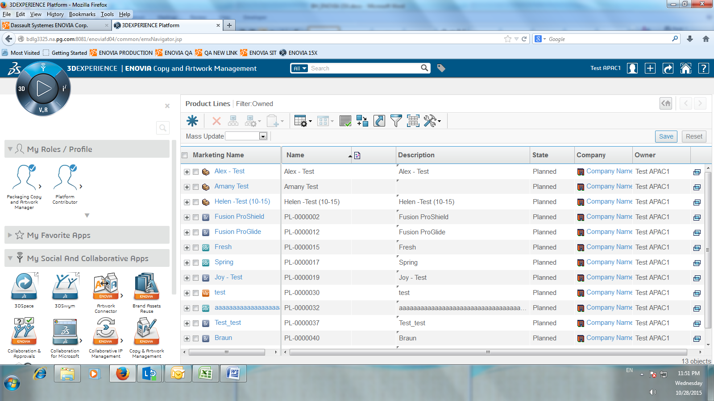

1. Click **Product Lines** under Product Line and then click the Brand name. (***Example:*** *Fusion Pro Shield*)

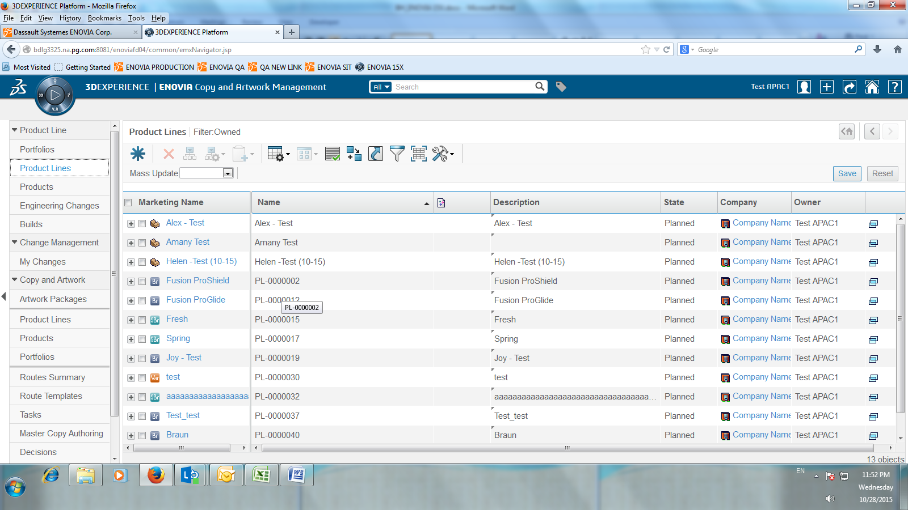

1. Go to the level where the POA is present. (***Example:*** *CPG level*)

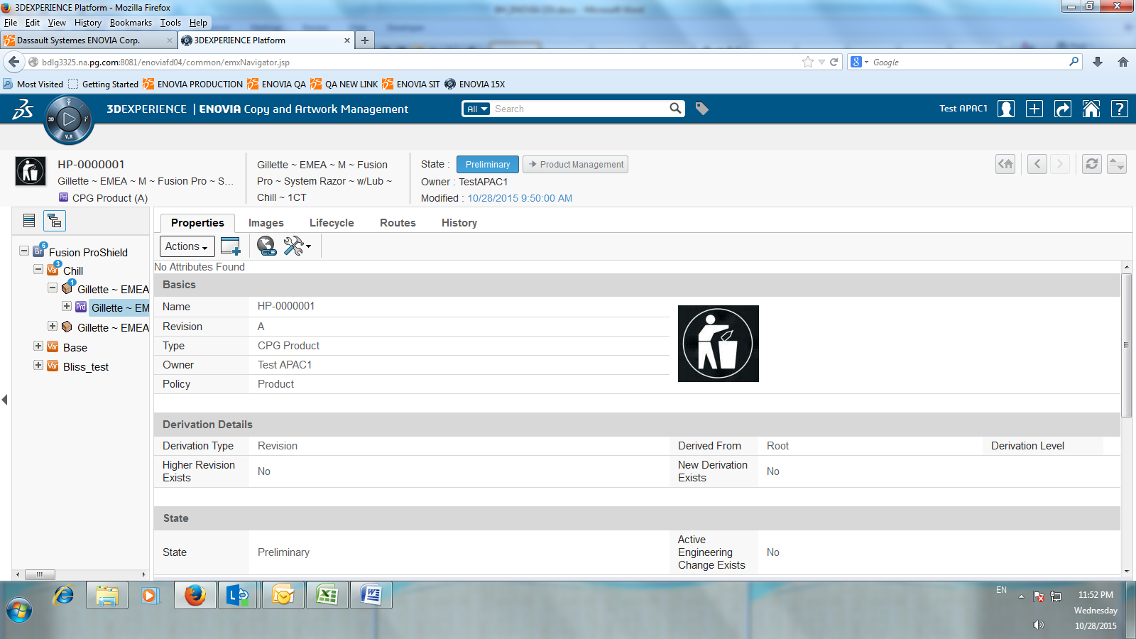

1. Click “**Categories**” then “**Copy and Artwork**” then select “**POAs**” tab.

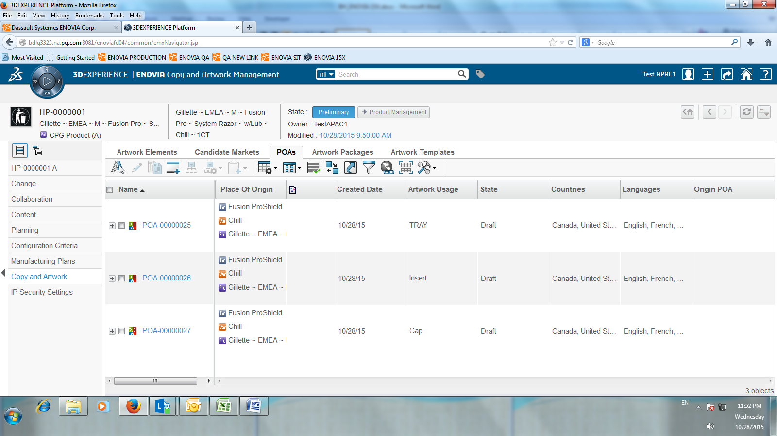

1. Mark the checkbox of the POA you are going to do the selective translation then click “**Edit POAs”** button

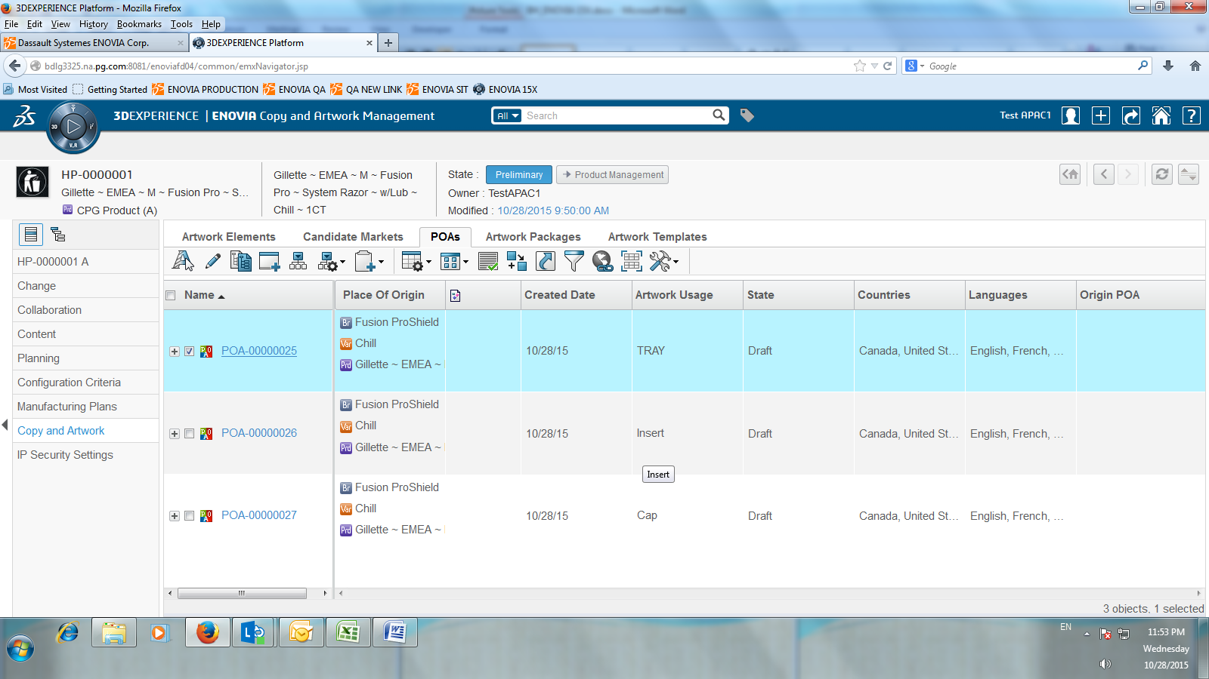

1. Edit POAs window will appear, select the language/s of the copy element to skip or include (*Tick or Untick*)

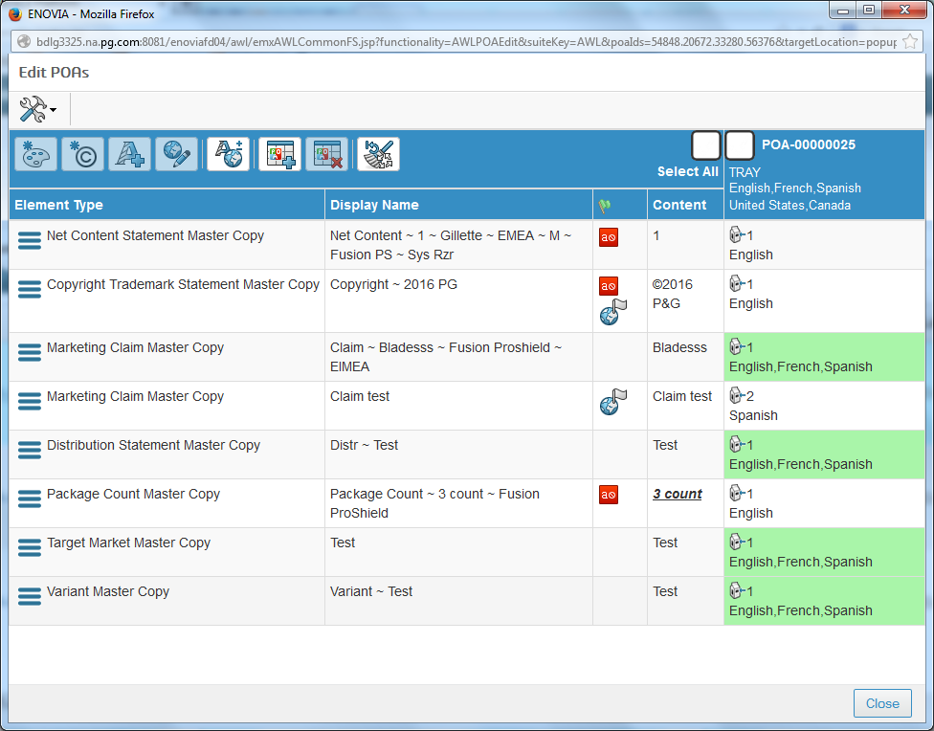

1. Click “**Add/Remove Local Copy**” then new window will appear at the right side, then skip or include language/s and click “**Save**” button.

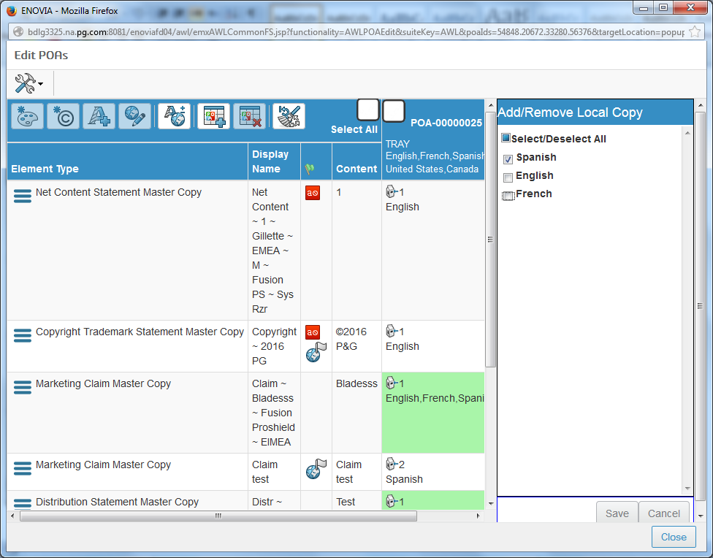

1. The language/s will now be reflected in the selected Copy Elements.

